Data Communication and Networks

Lab experiment 03

Name - Naman Dixit

Sap ID - 500125539

Batch - 7 Data Science

# Difference between Hubs and switches on the basis of working.

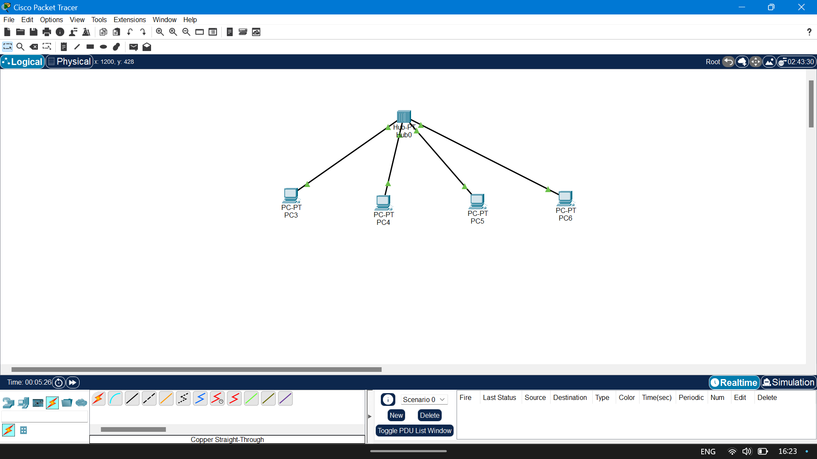

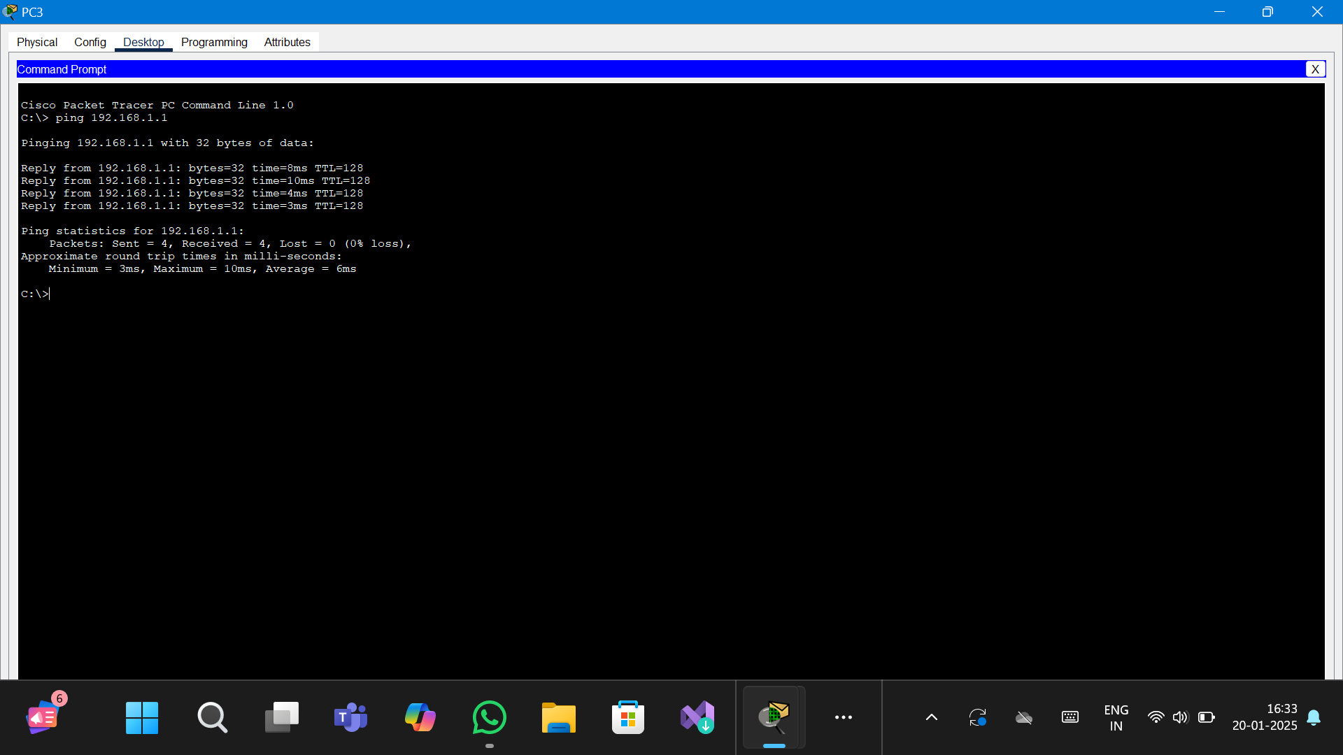

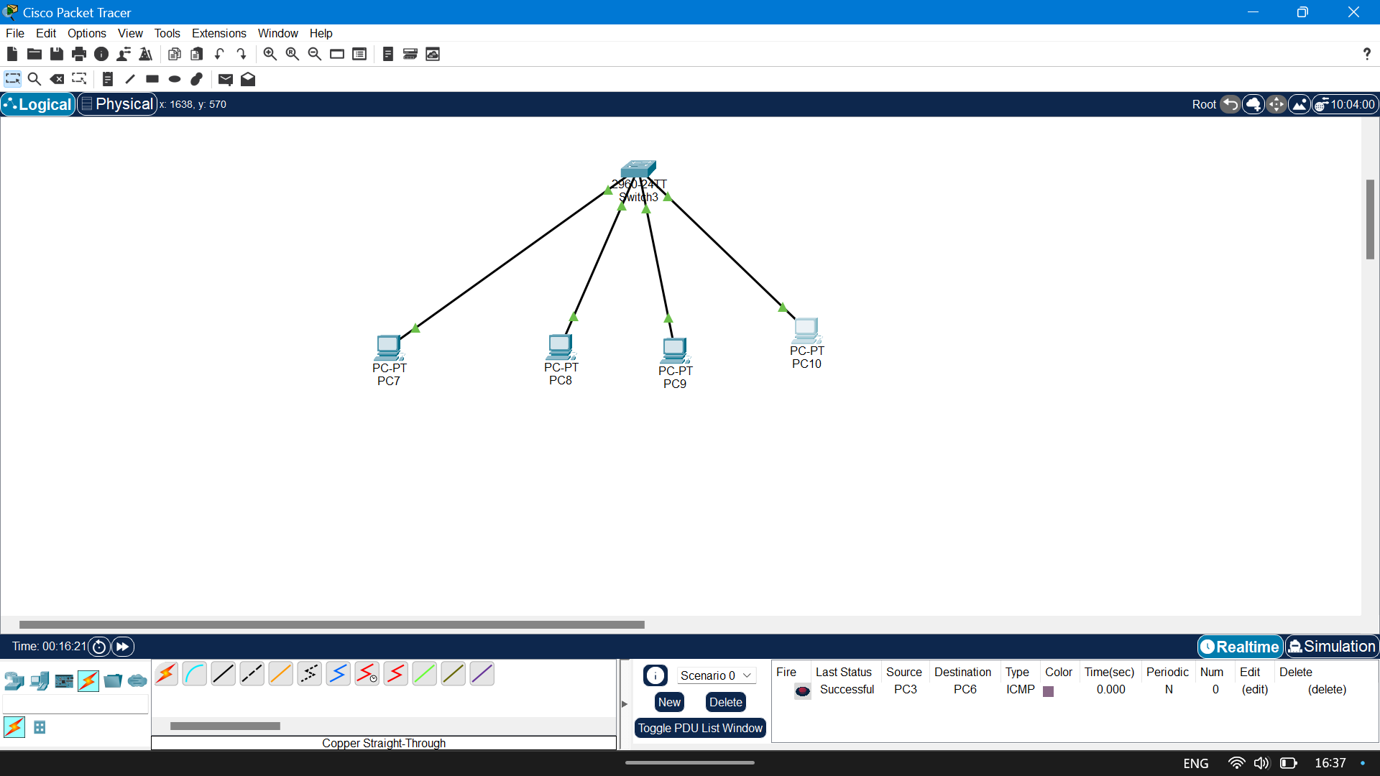

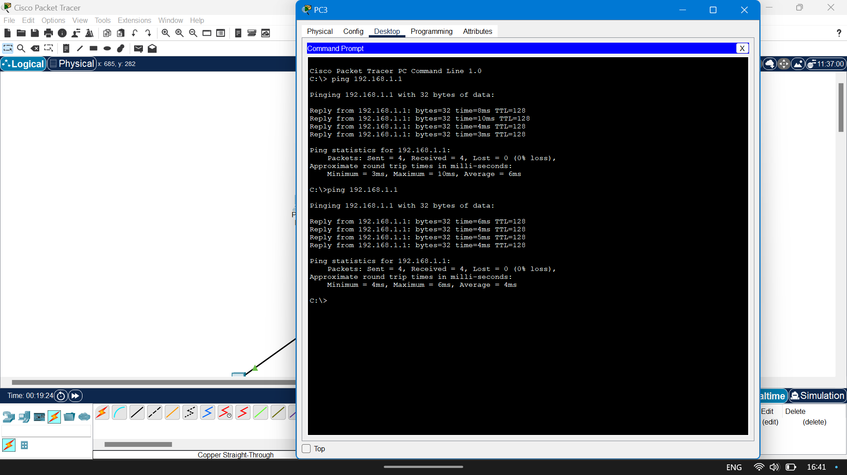

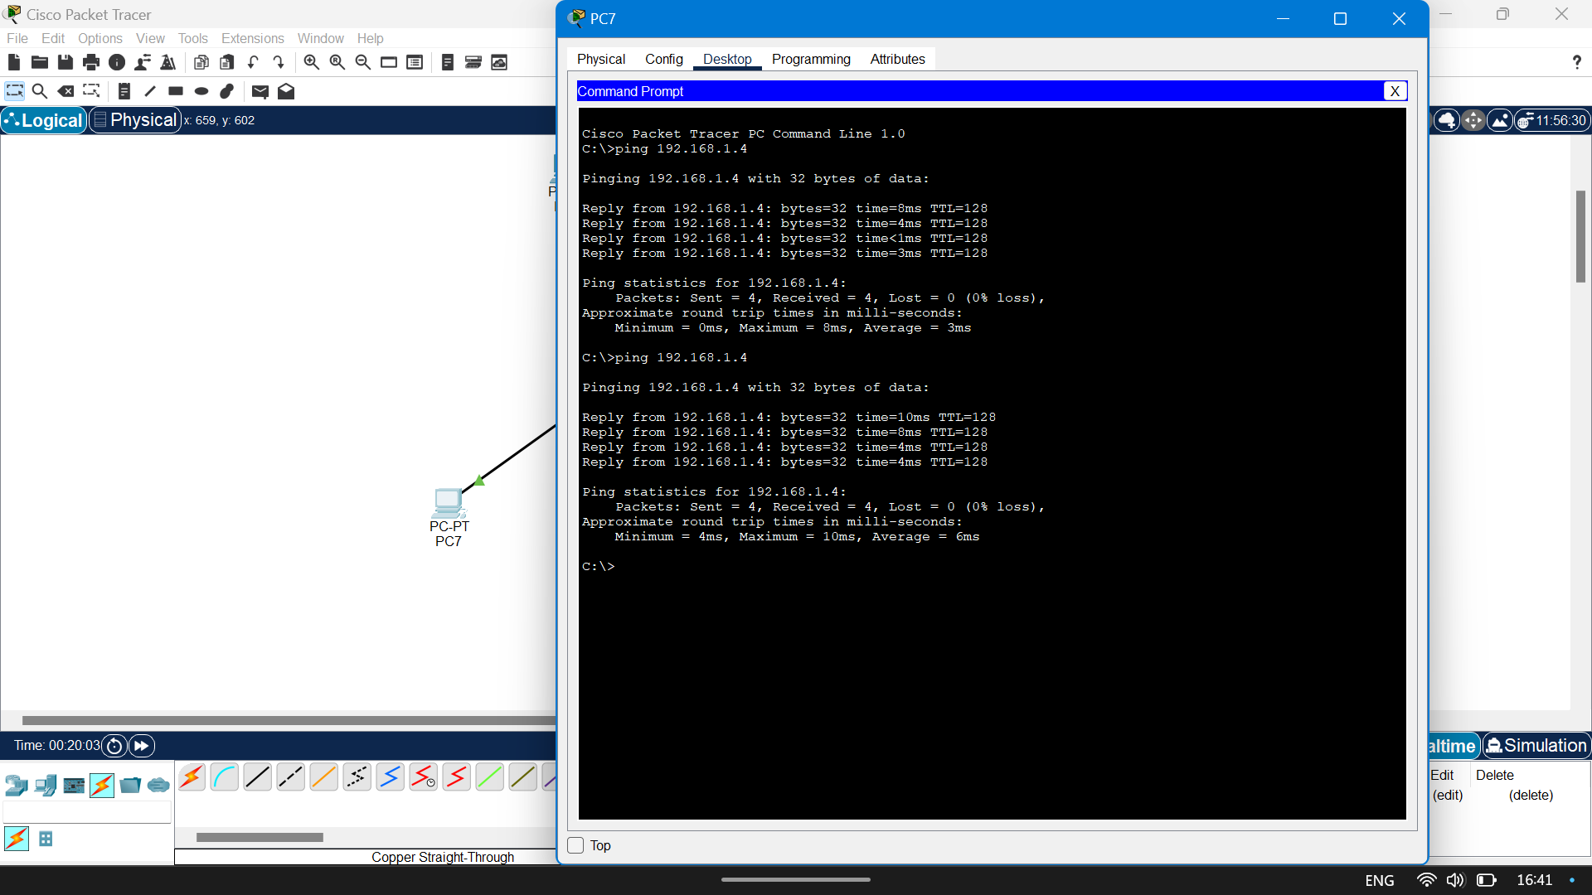

### 1. Working Mechanism

#### Hub:

* Layer of Operation: A hub operates at the Physical Layer (Layer 1) of the OSI model.
* Broadcasting Data: When a device sends data to a hub, the hub broadcasts the data to all connected devices regardless of the intended recipient. Every device on the hub receives the data, but only the device with the matching MAC address processes it.
* No Address Learning: A hub has no mechanism to identify or remember which device is connected to which port. It treats all devices equally and blindly sends data to all ports.
* Collision-Prone: Since a hub sends data to all connected devices, if multiple devices try to send data at the same time, collisions occur. This is known as shared bandwidth.

#### Switch:

* Layer of Operation: A switch operates at the Data Link Layer (Layer 2) of the OSI model, though modern switches can also operate at the Network Layer (Layer 3) for routing purposes.
* Selective Forwarding: A switch is an intelligent device that reads the MAC address of incoming data packets and forwards them only to the intended device, reducing unnecessary traffic on the network.
* Address Learning: Switches maintain a MAC address table that maps each device's MAC address to its corresponding port. This allows the switch to send data directly to the specific port where the intended recipient is connected.
* Collision-Free Communication: Each device connected to a switch has its own dedicated communication channel, allowing multiple devices to send and receive data simultaneously without collisions. This makes it more efficient than a hub.

2. Collision Domain

#### Hub:

* Single Collision Domain: All devices connected to a hub share the same collision domain, meaning they must compete for the same bandwidth. If two devices send data at the same time, a collision occurs, and the data must be retransmitted.

#### Switch:

* Separate Collision Domains: Each port on a switch represents a separate collision domain. This means that devices connected to different ports can communicate simultaneously without interfering with one another.

### 3. Data Transmission

#### Hub:

* Works in Half-Duplex Mode, meaning data can either be sent or received at a time, but not both.
* Uses Broadcasting to send data to all devices, which increases unnecessary network traffic and reduces efficiency.

#### Switch:

* Works in Full-Duplex Mode, allowing devices to send and receive data simultaneously.
* Uses Unicast (one-to-one communication) to send data directly to the intended device, and Broadcasting or Multicasting only when necessary.

### 4. Efficiency

#### Hub:

* Inefficient because it floods the network with unnecessary traffic by sending data to all devices.
* Suitable only for small, low-traffic networks where cost is a priority.

#### Switch:

* Highly efficient as it reduces unnecessary traffic and ensures data is sent only to the intended recipient.
* Ideal for modern networks where high performance and scalability are required.